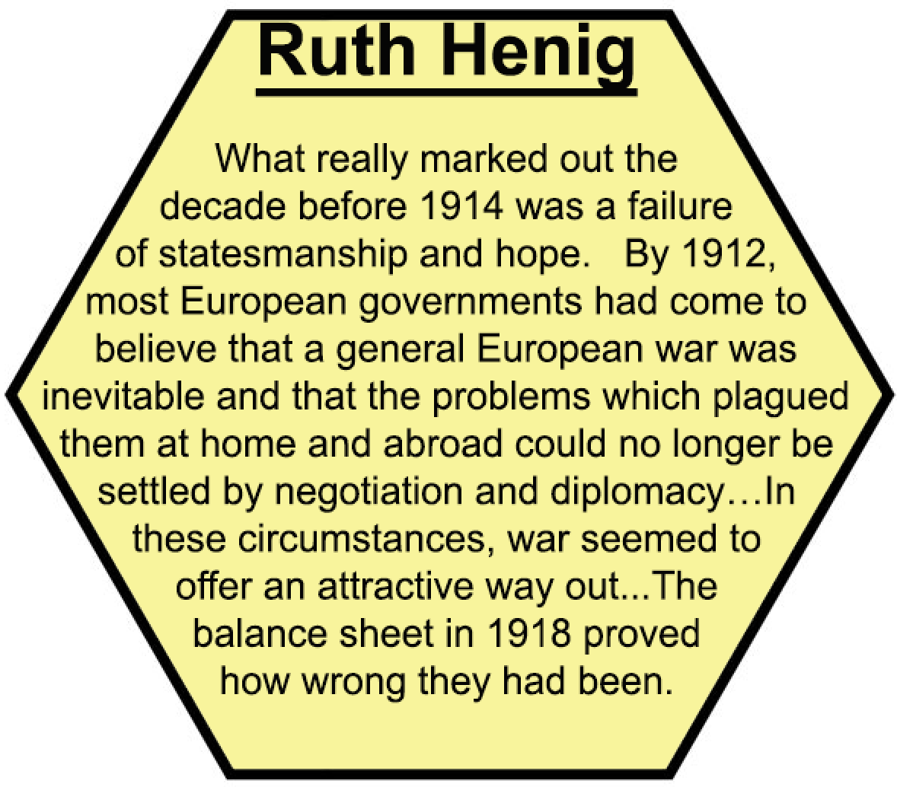
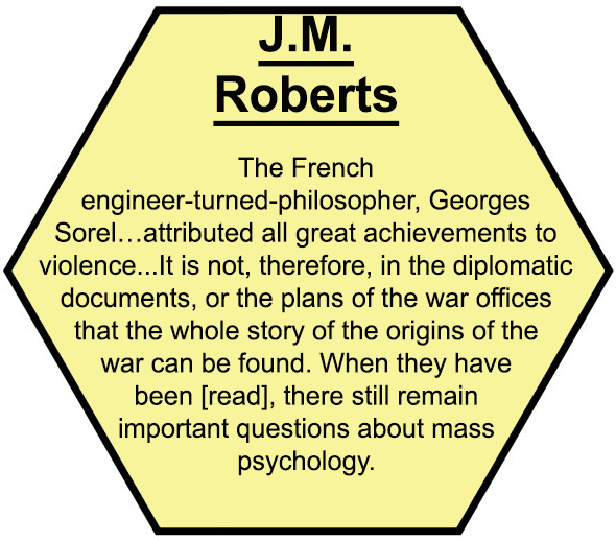
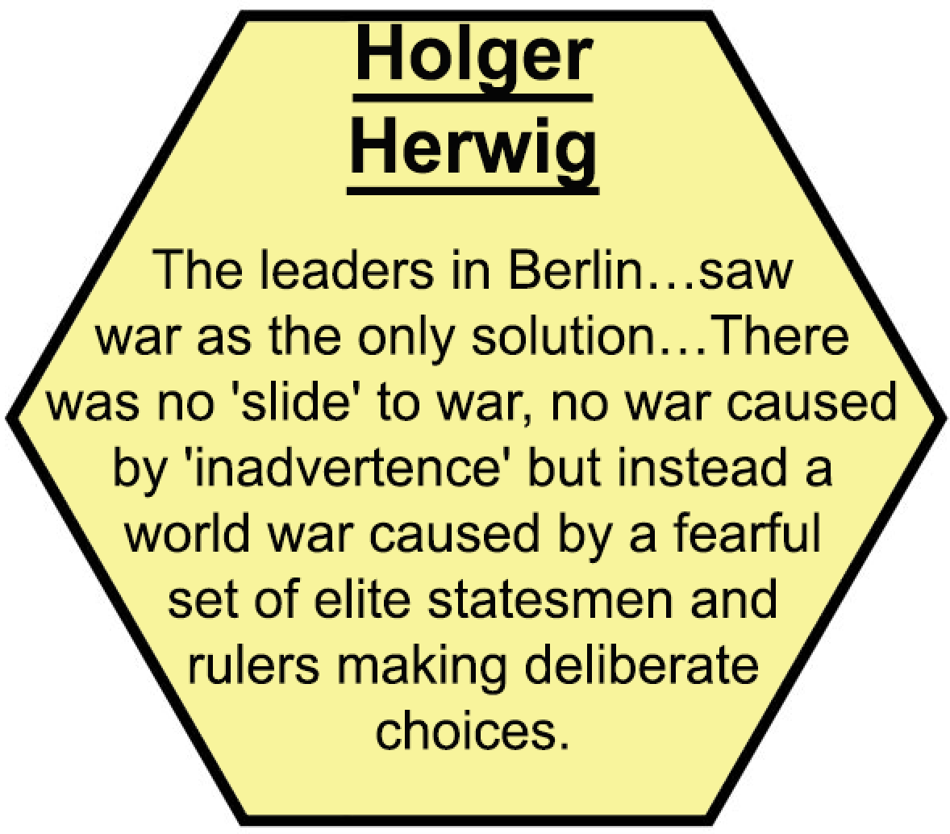
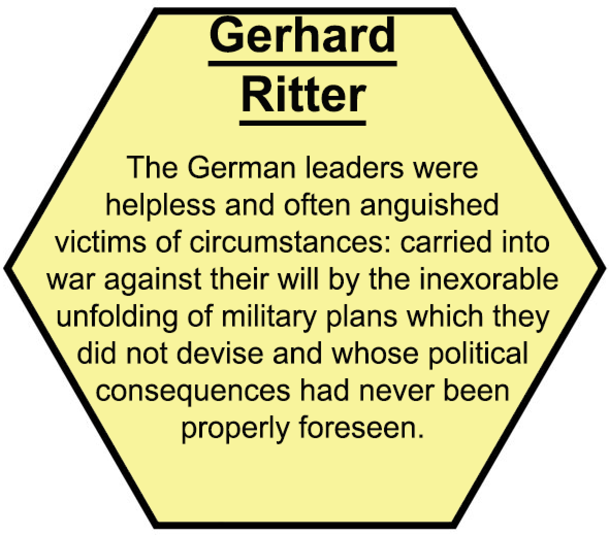
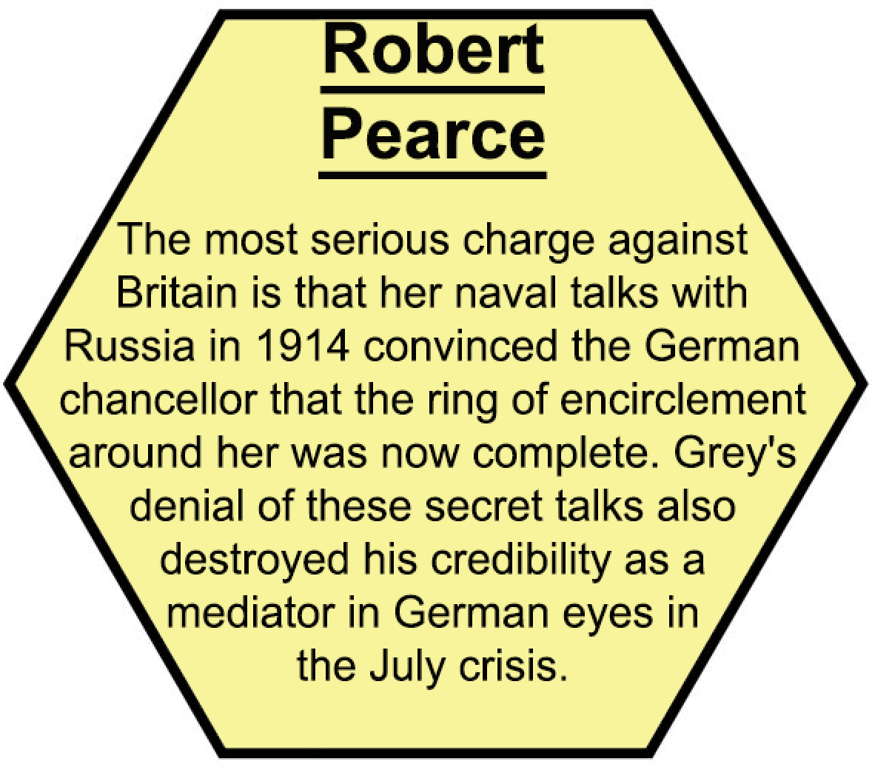
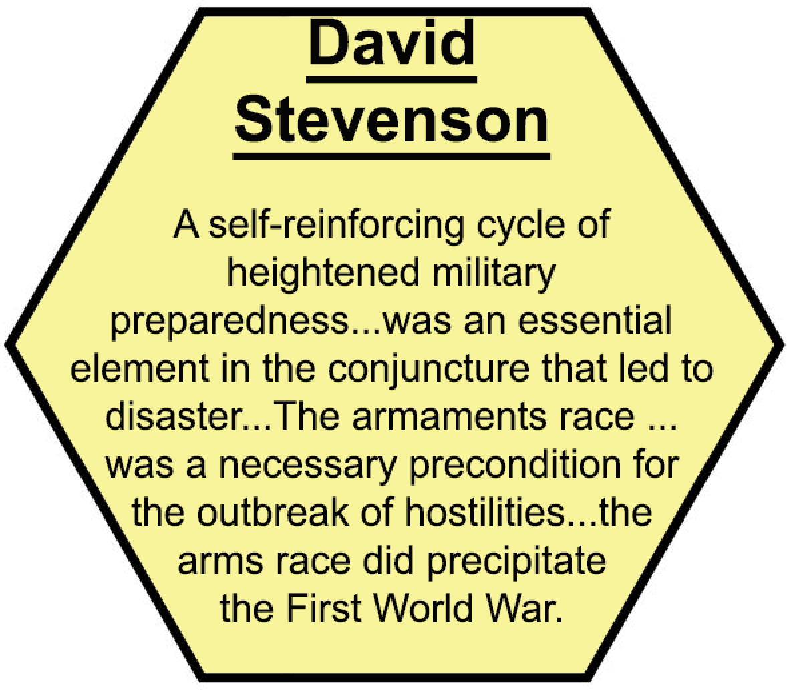
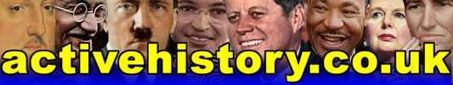
Dinner Party Historiography - The Origins of World War One
Directly after World War One, there was an immediate backlash against Germany, who was officially blamed for the war in the “War Guilt” clause of the Treaty of Versailles. However, in the 1920s old hatreds began to fade and some historians started to suggest that blame should be spread more widely. In the 1930s, the rise of Hitler led to the appeasers maintaining this compromising position, whilst anti-appeasers reinforced the traditional interpretation of German guilt to shore up their case for firm action against the Nazi regime.
Directly after World War Two, there was an immediate attempt to reintegrate Germany back into Europe, so many historians again leaned towards the ‘collective responsibility’ position with regard to World War One, and insisted that Hitler was a unique, unprecedented monster before World War Two. This is why the suggestion by AJP Taylor and Fritz Fischer that Germany was to blame for World War One, and that Hitler just picked up where the Kaiser left off, was so controversial.
In recent years the debate about responsibility for World War One has become more interesting still. Intentionalists within both camps focus on the actions and intentions of key individuals (and even the role of chance). Structuralists instead focus on the role played by institutions and social structures, with individuals becoming just pawns in an impersonal, almost inevitable tragedy.
The Dinner Party Seating Plan Challenge!
Here are 18 historians with different viewpoints about the Origins of World War One. Your job is to cut up these cards, read each one carefully, and arrange a dinner party reception designed to ensure that nobody ends up sitting adjacent to anybody that they will argue with too much, but will instead sit adjacent next to somebody or several people that they broadly agree with!
Work alone at first, then compare your ideas with a partner and with the class. Stick down your cards on sugar paper when you are happy with your seating plan, and provide a key to explain why each ‘table’ has been arranged in that particular way.
Discussion points: (a) Where would you seat yourself, and why? (b) If a fight was to break out between two tables of people – or two key individuals – which would they be, and why?



